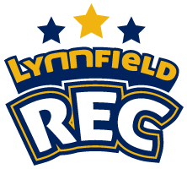

Field Use Guidelines & Handbook
January 17, 2018
Version 1.7

The Lynnfield Recreation Commission reserves the right to update and revise the contents of this field policy and permit handbook at any time

Table of Contents

I. Overview and Authority 3
Lynnfield Recreation Mission Statement 3
Purpose 3
Jurisdictional Authority 3
II. Permitting, Definitions and Permitted Uses 3
Permitting 3
Definitions 3
Permitted Uses 3
III. Organization Categories and Priorities 3
User Organization Categories 3
Priority Uses 3
IV. Field Overview 3
Field Designations and Description 3
V. Permits, Fees and Fines 3
Permit Application Process 3
League/Organization Season Use Fees 3
Casual User 3
Clinics and Camps 3
Special Events 3
Fines 3
Appeals Process 3
VI. Field Maintenance Standards, Roles & Responsibilities 3
Field Maintenance Standards, Roles & Responsibilities 3
VII. TERMS, CONDITIONS, & LIMITATIONS 3
Weather Conditions and Impact on Field Usage 3
Field Rotation and Suspended Use 3
Document Control 3

Overview and Authority

Lynnfield Recreation Mission Statement

The mission of the Lynnfield Recreation Commission is to enrich the lives of Lynnfield residents through abundant quality programs, events, fields and facilities.

Purpose

The purpose of this document is to define the terms of use, and required procedures for the Town of Lynnfield’s fields and to:
- Ensure fair and equitable process for determining priority of use.
- Designate usage fees.
- Communicate requirements, processes and rules of use.

Jurisdictional Authority

The Lynnfield Recreation Commission (hereinafter referred to as LRC), with jurisdictional responsibilities, together with the Athletic Department (hereinafter referred to as AD) of the Lynnfield School system, seeks to provide clean, organized, well maintained and safe athletic fields within the Town of Lynnfield.

- The Lynnfield High School Athletic Director has primary authoritative use over the school athletic fields during school hours. The Lynnfield Recreation Commission has the primary authoritative function of managing the field use after school hours.
- Based on changes to the school athletic schedules, for any reason, the Athletic Director will notify the Lynnfield Recreation Commission that a given field may be required for school athletic functions.
- Lynnfield Recreation Commission will contact the effected athletic organization to adjust their schedule.
- The effected athletic organization will be responsible for notifying all parties impacted by the change.
- The Lynnfield Recreation Commission has jurisdiction for all other town owned non-school athletic fields/events.
- The Lynnfield Recreation Commission will coordinate all field maintenance with Lynnfield Department of Public Works (hereinafter known as DPW) for the benefit of all field users.
- Special circumstances will be addressed on a situation by situation basis and the user will be responsible for all costs.

Permitting, Definitions and Permitted Uses

Permitting

- All Lynnfield organizations utilizing a field in Lynnfield will be required to have Lynnfield Recreation Commission practice and game permit(s).
- A detailed practice (where applicable) and game schedule will be provided to Lynnfield Recreation Commission by the end of July for the fall, by the end of February for the spring and by the end of May for the summer.
- Lynnfield Recreation Commission will be flexible with an organization that has a practice schedule but is awaiting a league issued game schedule to issue game permits.

Definitions

- Organized Activity: Any group of individuals that communicate and meet on a regular basis.
- Permit: Document(s) provided by the Recreation Commission, including but not limited to a calendar of approved dates and organizations, Regulations for Use, and safety information.
- Priority use: The order of preference when allocating the use of facilities to organizations.
- Nonprofit: an organization formed as a 501(c)(3) for which proof must be provided including certificate copy of constitution and table of organization with list of paid employees.
- For-profit: any business, group, individual organization not certified as a 501(c)(3).
- Traditional use: includes but not limited to, practices, games or meets between two teams.
- Special events: includes but not limited to, clinics, tournaments, round robins, practice only organizations, charity events, carnivals, multi inning/quarter games, approved only for events sponsored by Lynnfield Recreation Commission, Lynnfield public schools or Lynnfield-based nonprofit organizations.
- Casual User: An individual or organization not associated with at team, league or group that has field use for not more than one day per season (e.g. one-time events such as birthday parties)
- Turf Fields Complex: the entire area inside the fences that separate the complex from the parking lots excluding the high school.
- Standing water: puddles that remain on the facility surface after inclement weather.
- Authorized maintenance: tasks undertaken by an organization, approved in advance by the Recreation Commission and the DPW director.
- Legacy organization: a Lynnfield-based organization that has used facilities for several years prior to the establishment of updated policies in 2013. Recreation Commission to provide a list of these organizations upon implementation of this policy.
- Waiver: a determination made by vote of the majority of the Recreation Commission and/or board of selectmen that a specific organization may not meet all requirements for priority user group, But is determined eligible based on written documentation provided that determines organization's value to the community or requirements of League.
- Lynnfield residency: In order to be considered 100% Lynnfield residency, the participants must live in Lynnfield, attend Lynnfield public schools, or a private school located in Lynnfield.
- Spring season: April 1 through 3rd Sunday in June (Lynnfield High may start prior to April 1 based on MIAA schedule).
- Summer season: Monday immediately after 3rdSunday in June through August 15.
- Fall season: August 15 through the3rd Sunday in November (Lynnfield High may use fields through Thanksgiving and postseason game schedule).
- Senior field: those generally used by high school, adults and older youth,
- Junior Field: those generally used by elementary aged and younger youth.
- Field maintenance Fee: fee charged to assist with costs related to maintenance of facilities that is deposited into a designated fund within the Recreation Commission Revolver Account.
- Field Administration Fee: Fee charged to account for the cost of the administrative tasks undertaken by the Recreation Commission and deposited into the Recreation Commission Revolver Account. Capital Improvement Fee: fee charged to save for major renovations, improvements and major maintenance projects (e.g. replacement of turf) to be deposited into The Recreation Capital Trust Fund.

Permitted Uses

- Organized activity (not to include Lynnfield public-school events) held at Lynnfield’s parks, athletic fields in related facilities must show require a permit.
- All permit applications must be submitted in writing to the Recreation Commission. Applications received past established deadlines will be processed on an as available basis, regardless of priority status. No action will be taken on incomplete applications.
- Request to use athletic fields upon extended team by the Recreation Commission to be non-traditional or that will replace a higher burden on the facility than typical use must be put in writing on a special event request form. Special events must be approved by the Recreation Commission and or the Board of Selectmen.
- Facility allocation will be managed by the Recreation Commission and will be based on the categories listed in the next section, but may also take into account field conditions, scheduled renovations, age and history of organization, past practices of organization (positive or negative), age-appropriate sized facilities, and impact on the neighborhood.
- In general, younger youth groups will be scheduled on Junior (smaller) fields and older youth groups and adults will be scheduled on senior (larger) fields.
- Priority use on 60 foot and 90 foot diamonds is given to baseball and softball organizations: priority for multi-purpose fields will be given to organizations that play on rectangular fields, including but not limited to football, soccer, lacrosse and field hockey.
- All permit holders agree to abide by the most current set of regulations for use as provided by the Recreation Commission.
- An athletic field with standing water is automatically closed. No unauthorized maintenance work may be done to move the standing water and use the closed field. League designees, The DPW or Lynnfield Recreation may close the fields due to weather conditions in order to protect them. Permits may be revoked from organizations along use of athletic fields with once they have been closed, and a fine may be charged to cover the costs of repairs in needed.
- A representative of the organization holding the permit must be present at the facility while in use to be able to answer questions and ensure that all regulations are followed. Representative may be a coach or a league official.
- All trash must be removed from the field and facilities and placed in proper trash receptacles. The permit may be revoked from organizations leaving trash behind after use.
- The police department will be notified when organizations allow coaches, parents, and/or participants to park illegally, or obstruct access to neighborhood homes or access for safety vehicles.
- A permit may not be sublet to a different organization. The Recreation Commission will work with permit holders on any exchanges if both permit holders agree to the exchange. Unauthorized permit subletting shall result in immediate loss of permit.
- Permits may be revoked if an organization, its coaches, players or parents and observers do not abide by the regulations for use, or allows the facility to be damaged with action or in actions. Organizations with revoked permits maybe be denied future permits and or face fines per section
- Reimbursement will not be given for revoked permits.

Organization Categories and Priorities

User Organization Categories

These categories place non-school/non-Park and Recreation organizations into scheduling categories that are listed in the following priority use levels.

Category A
- Lynnfield Non-Profit Youth Organizations
  - 100% Lynnfield Residents (as detailed in the definitions section above).
- Youth Legacy Organizations
- Game and Practice Schedules, only

Category B
- Lynnfield Non-Profit Adult Organizations
  - 100% Lynnfield Residents (as detailed in the definitions section above).
- Adult Legacy Organizations
- Game and Practice Schedules, only

Category C
- Lynnfield Non-Profit Youth and/or Adult Organizations
- Less than 100% Lynnfield Residents (as detailed in the definitions section above).
- Regional Non-Profit Teams based in Lynnfield (Select, AAU, etc.)

Category D
- Non-Lynnfield Non-Profit Organizations

Category E
- Any other organization not listed in Category A-D

Priority Uses

The Recreation Commission shall use the following priority order as a determining factor for providing permits, along with those listed above. Groups listed in each level have equal standing.

Level I
- Lynnfield Public School: weekdays 7:30AM-3:00PM (September-June)
- Lynnfield Public School: Pre-season and post-season activities, as determined by the MIAA
- Lynnfield High School Athletics: Weekdays from 3:00-6:00PM (September-June)
  - Priority Order: Varsity, Junior Varsity, Freshman, Middle School, Clubs/Activities
- Lynnfield high school athletics conference league games, including varsity football, soccer, lacrosse and field hockey night games (September to June). Varsity football will be allowed up to four night games per season (September to November). Other Varsity teams will be allowed a maximum of two (2) night games for varsity team per season defined as: Fall boys and girls soccer: field hockey, spring boy's and girl’s lacrosse, girls’ softball, boy’s baseball (if field is lit).
- Lynnfield Recreation Commission sponsored programs Lynnfield public school PTO events at their own school (September to June).
- Approved special events of current permit holders.
- User organizations category A: weeknights and weekends (September to June).
- General guidelines on hours of use on school fields: 6:00-9:00PM lit fields 6:00PM to dusk unlit fields, 8:00AM start on weekends: individual field guidelines as shown below.

Level II
- Lynnfield high school Athletics: weekends (September-June).
- Includes practices, non-league games and scrimmages.
- Lynnfield high school athletics, nights (September-June) excluding level one definition.
- Includes practices, non-league games and scrimmages.

Level III
- User organizations Category B

Level IV
- User organizations category C
- Special events from organizations not holding permit in that season

Level V
- User organizations category D and E
- Late applications
- Organizations that are affiliated with Youth Sports organizations that collect their own fees.

Field Overview

Field Designations and Description

The following descriptions and user designations are for fields that are currently projected as part of the "New Fields Plan":

Field Names & Numbering
- High School
  - HS1 Multi-purpose Stadium field with lights
  - HS2 Multi-purpose field closest to the wetlands
  - HS3 Multi-purpose field closest to the school with lights
  - HS2/3A 90’ Softball Diamond using fields HS2 and HS3
  - HS4 90’ Baseball diamond
  - HS4A Multi-purpose field (fall only)
  - HS4B Multi-purpose field (fall only)
  - HS5 60’ Softball diamond
  - HS5A Small multipurpose field
- Middle school
  - MS6 Multi-purpose senior field located inside the track
  - MS6B Track located outside field MS6
  - MS7 90’ Baseball diamond
  - MS7B Multi–purpose field located in the outfield of baseball field
  - MS8 60” Softball diamond
- Summer Street School
  - SS9 60’ baseball field on side of the school
  - SS10 60’ baseball/softball field at the rear of the school
  - SS10B Multi-purpose in the outfield of baseball field
- Huckleberry Hill School
  - HH11 Multi-purpose junior field to the side of the school
- Maria Goretti
  - MG12 Softball diamond
  - MG12B Multi-purpose junior field in right field of the softball field
- Glen Meadow
  - GM13 60’ Baseball diamond
- Newhall Park
  - NH14 Newhall Front
  - NH15 Newhall Back
- Jordan Park
  - JP16 Multi-purpose field
  - JP17 Multi-purpose field
  - JP18 Multi-purpose field
The use of any field by any organization other than Lynnfield Public Schools and all uses of any field by the Lynnfield Public Schools except for the specific time periods and locations denoted above shall require a permit by the Lynnfield Recreation Commission.
(INSERT FIELD PICTURES/MAPS)
Figure 1 High School
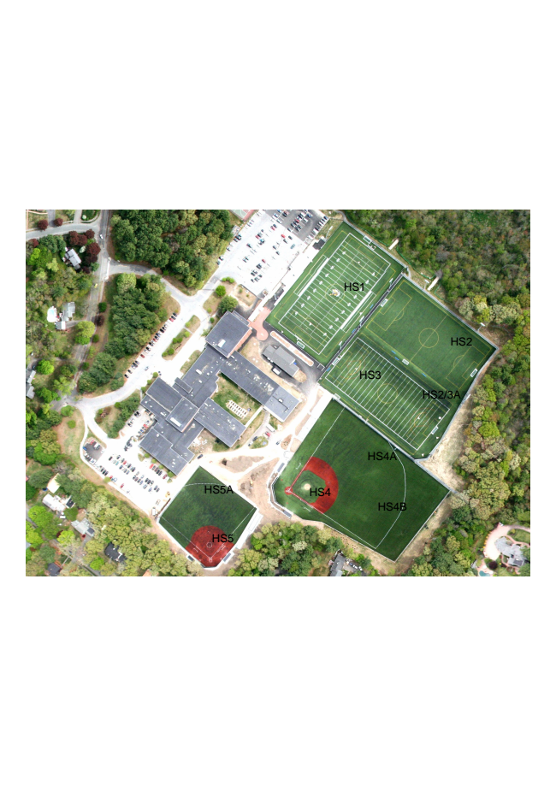
Figure 2 Lynnfield Middle School
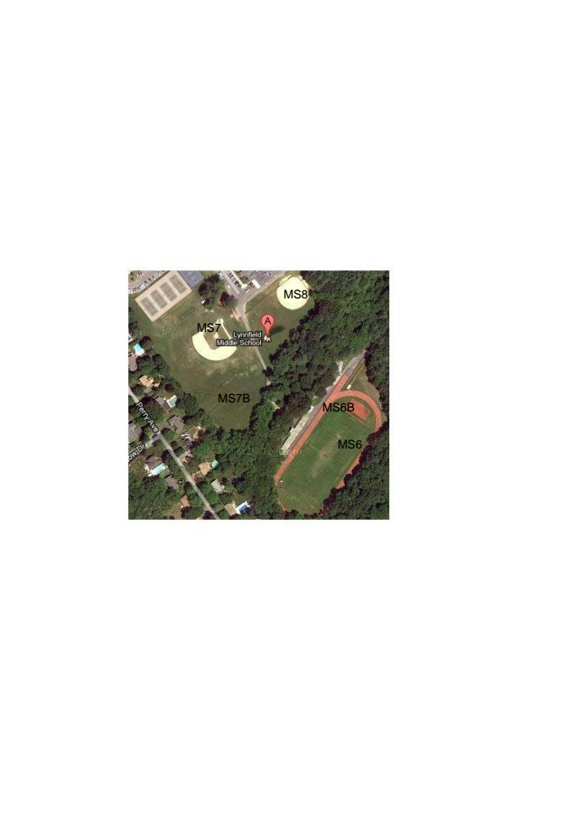
Figure 3 Summer Street School
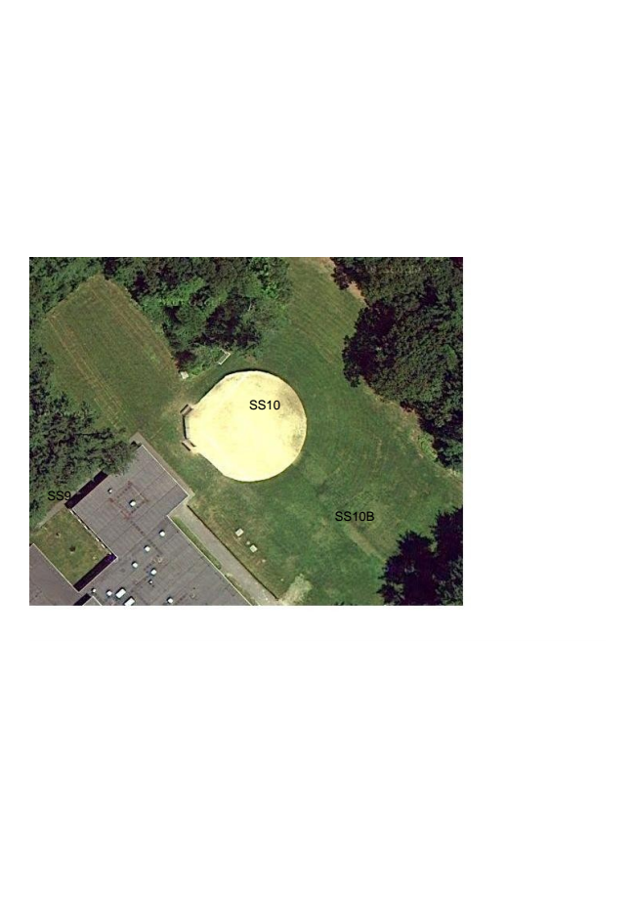
Figure 4 Huckleberry Hill School
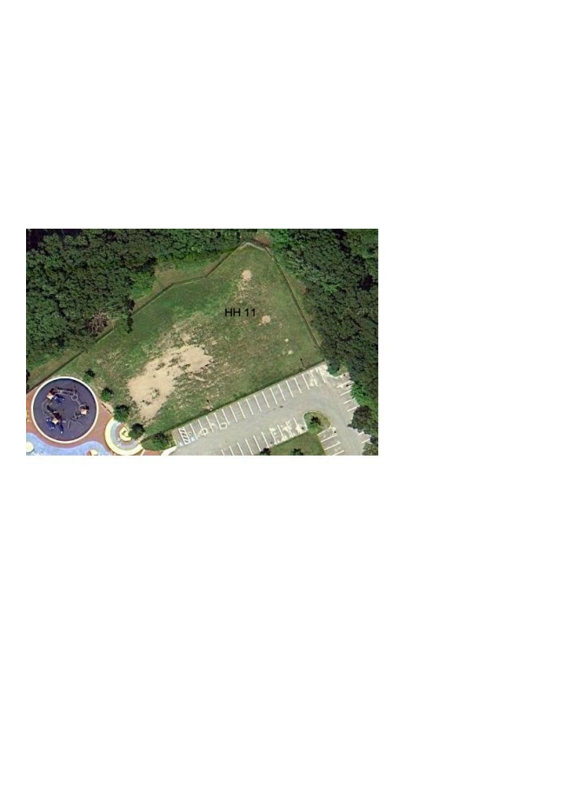
Figure 5 Maria Goretti
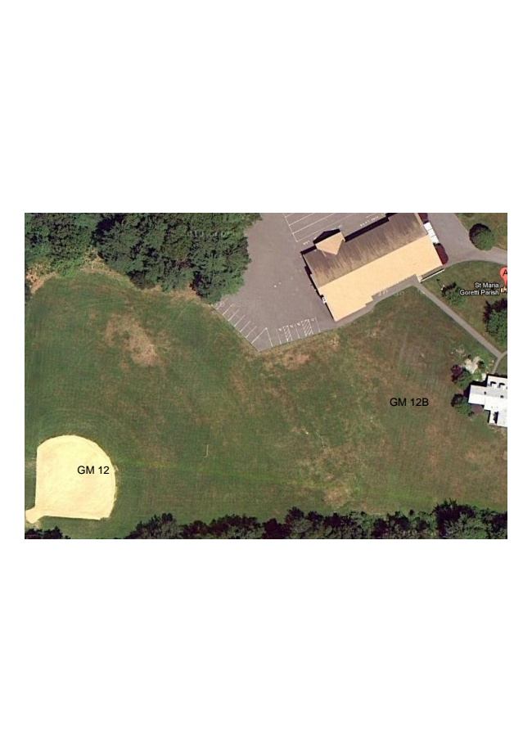
Figure 6 Glen Meadow
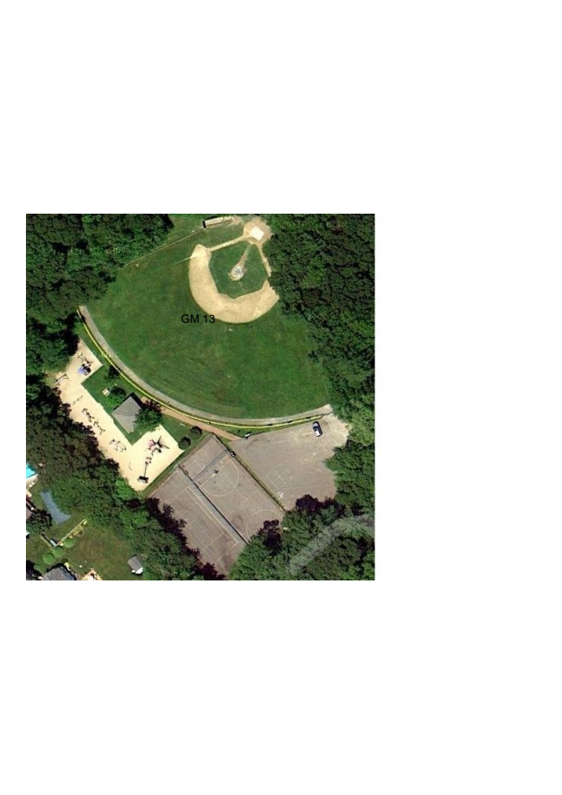
Figure 7 Newhall Park
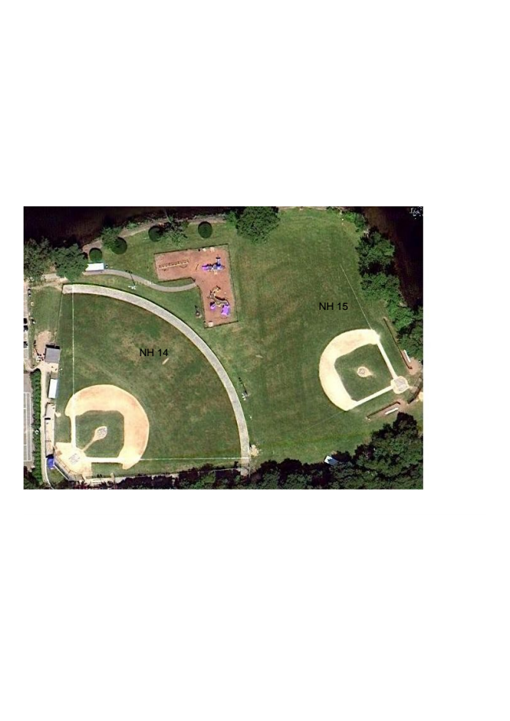
Figure 8 Jordan Park
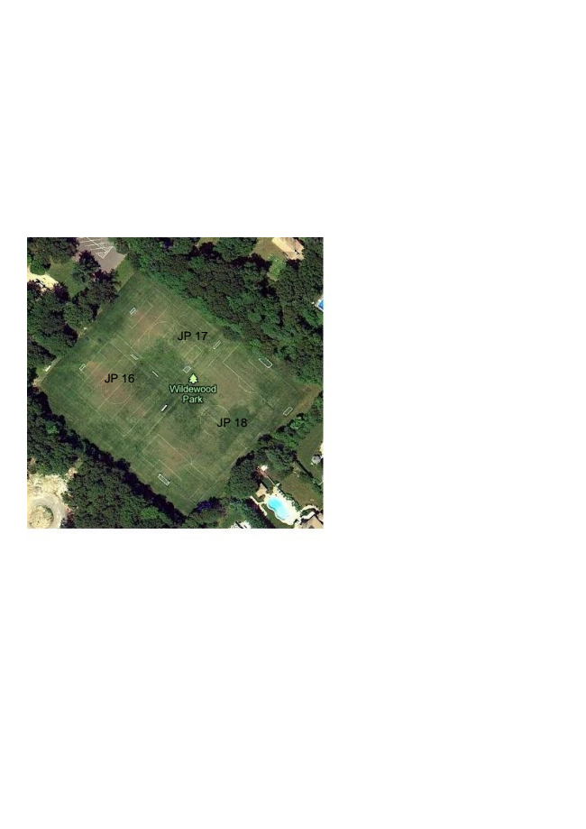

Permits, Fees and Fines

Permit Application Process

Permit applications must be submitted on an official form or online as provided by the Recreation Commission. All required forms must be submitted in order for action to be taken on the request. No action will be taken on incomplete applications. Required forms include, but are not limited to, contact information, specific dates/schedules, insurance certificates, and signed agreements.

Applications must be submitted within the required timetables, as indicated below. Level eligibility will not be honored with late or incomplete applications.

Season | Due Date: Schools, Special Events | Due Date: All Others | Permits Issued by:
Spring | 15-Jan | 30-Jan | 15-Mar
Summer | 15-Mar | 30-Mar | 30-Apr
Fall | 1-Jul | 15-Jul | 15-Aug

An organization that has held a permit in the past but is changing its program to include additional teams, additional age levels, or other change to the prior season schedule for games/practices must submit these changes in writing on a "New Program" form.

An organization that has not held a permit in the past must provide all information about its organization in writing on a "New Program" form. The organization must include all documentation for the organization as delineated under "non-profit" in definitions.

Permit Application Required Documentation
Required by the seasonal due date:
- Permit application.
- A roster including the names and addresses of all registered participants as of permit application date.
- Payment of $30 per registered participant for all participants included on the roster submitted with application.
- Schedule of games and tournaments including times for the fields requested.
- List of current Board of Directors (with Titles) and Field Manager including e-mail and cell phone information.
- Confirmation in writing by the League/Organization President that CORI checks have been completed on all coaches, volunteers or anyone involved with children less than 18 years old.
- Copy of the Comm. Of Mass Attorney General – Certificate of Solicitation or confirmation in writing that non-profit league/organization is in compliance with the IRS 501(c)(3) charitable guidelines or Massachusetts non-profit requirements.
- Copy of most recent IRS Form 990/990-EZ with detailed income and expenses
- Copy of by-laws, code of conduct and disciplinary guidelines.
- Copy of a Certificate of Insurance General Liability naming the Town of Lynnfield as an additionally insured party for a minimum of $1,000,000 per incident coverage and $2,000,000 aggregate general liability coverage.
- Copy of the signed Lynnfield Recreation Indemnity Clause & Disclaimer by League President.
The above must be submitted in order for the application to be processed. If you are not a 501(c)3 group, you must submit a financial statement in lieu of Item #8. If you have current or up to date contact information and by-law information on your website, you do not have to submit #5 and #9.

Required Within Two Weeks after Final League Deadline:
- A final roster including the names and address of all registered participants as of the date that the league will no longer accept registrations.
- Payment of $30 per registered participant for the difference between the payment made at permit application and the total due based on the final roster submitted.

Any league or organization not disclosing the final rosters and payment will be subject to our disciplinary policy.
Permit Application Procedure
- All applicants must be at least 18 years of age to apply for a permit with the Recreation Department. The applicant or authorized representative (league official or coach) must be present throughout the entire use of the rental.
- The first step in reserving any facility (park or athletic field) is to make a request. Requests should be made in writing through the Recreation Department (Town Hall). You must go to our website and download the request form (http://lynnfieldma.myrec.com/info/default.aspx) and submit it to Joe Maney or Julie Mallett
- Applications that have been received previously are not automatically renewed and there is no guarantee year to year for field availability.
- Permits will not be issued without a payment and any documentation required or directives issued. No use may commence without a permit.
- With increasing demands for use of athletic fields and park uses, the Recreation Department may not be able to accommodate every application or request. Therefore, the Recreation Department reserves the right to use its priority system and/or its discretion when issuing permits.

Lynnfield Recreation
Indemnity Clause & Disclaimer
I have read, understood and agree to all of the rules, regulations, terms, conditions and limitations listed in the Lynnfield Recreations “Field Use Policy Handbook” and understand the consequences of not complying with these policies. In consideration of being permitted to use the Lynnfield Recreations fields and facilities, I, on behalf of the members and players from my organization, league or group, shall indemnify, defend and hold the Town of Lynnfield, its departments, employees and officials harmless from any and all claims, demands, liabilities, actions, cause of actions, cost and expenses, including attorney fees arising out of the use of the playing fields, parks, facilities and equipment. Any one person or group utilizing any Lynnfield Recreation facilities, fields, parks, and equipment will do so at their own risk.
The permit will be immediately revoked for the use of alcohol, any illegal substance, and violation of the law and any behavior deemed inappropriate by the Lynnfield Recreation Department or Committee or his duly appointed representatives. If at any time an unfavorable condition exists or conduct by a participant or participants is deemed inappropriate, the Fields Director or his duly appointed representative reserves the right, in the interest of public safety, to discontinue all activities or dismiss the person or persons detrimental to the activity.
All incidents or accidents should be reported to the Lynnfield Recreation Department immediately.
My signature below indicates that I have read and agree to the above disclaimer, received and read a copy of the “Field Use Policy Handbook”, and will fully abide by the terms, conditions and provisions contained or referred to therein.
___________________________ _________________________
Signature of Applicant/League President Organization/League
Address: ______________________________________________________________________
Street City State Zip Code
Home #:________________________________________ Work #: __________________________________
Cell #: _____________________________________ Email: __________________________________________
IF YOU MAKE AN ELECTRONIC REQUEST AND RECEIVE A RESERVATION/PERMIT, PLEASE NOTE THAT PAYMENT AND/OR PARTICIPATION CONSTITUTES ACCEPTANCE OF OUR FIELD & FACILITY PERMIT POLICIES INCLUDING THE INDEMNITY CLAUSE & DISCLAIMER.
Lynnfield Recreation
Disciplinary Actions/Policy

- Verbal warning to permit applicant.
- Written warning to permit applicant.
- Permit suspension.
- Permit revocation.

➢ Any individual and those governed within a league,
team or group who has violated our policies, we reserve the right to ban said individual from our parks, fields and facilities.

➢ If a league, team or group does not follow their by-
laws or disciplinary actions, we reserve the right to revoke their permit.

League/Organization Season Use Fees

The field usage fees apply to all fields listed in the section IV.
- $30.00 per participant per season.
  - $15.00 of which is deposited as a FIELD MAINTENANCE FEE.
  - $5.00 of which is deposited as a FIELD AMINISTRATION FEE.
  - $10.00 of which is deposited in the Recreation Capital Trust Fund for large and/or long-term capital projects e.g. new facilities, improvements and major maintenance (turf replacement).

Casual User

- Resident: $25/ 2-hr block per field.
- Lights for HS1 Stadium Field: $35 per 2 hr. block (regardless of how long lights are on)

Big Diamond Baseball Field
- Turf $150/30 minute warm up with 2 hr. game
- Grass $120/30 minute warm up with 2 hr. game
If the game before you runs long then you lose your 30 minute warm up time

Clinics and Camps

- Fees may not be charged when an event is an approved special event for members of a permitted organization during its regular season.
- Clinics and camps being run by a Lynnfield Organization and Lynnfield Public Schools for the benefit of its members but outside of the regular season shall be subject to the following fees:
  - $5.00 per person per day for Lynnfield residents (proof of residency is required).
  - $10.00 per person per day for non-Lynnfield residents at clinics/camps (proof of residency is required).
  - 75% of the fees will be deposited into the Recreation Capital Trust Fund for fields and facilities.
  - 25% of the fees will be deposited Recreation Revolving Account for 20% Field Maintenance & 5% Administration.
  - This section is not intended to include Lynnfield teachers and coaches who are conducting training camps and clinics for which a fee is charged. These clinics and camps would fall under SPECIAL EVENTS as shown below.

Special Events

Organizations interested in running special events (such as but not limited to the following) clinics, tournaments, round robins, charitable events, carnivals, multi-inning/quarter games must submit a Special Events Request Form to the Lynnfield Recreation Commission.

The Lynnfield Recreation Commission will determine the events that fall under this fee structure, based on the type of organization making the request, type of use, and the purpose of fees collected for the event. In general, Special Events officially sponsored by and/or financially benefiting the Recreation Commission, Lynnfield Public Schools will not be charged. All other organizations whether affiliated with a local league or not will be subject to the following fees:
- For events four (4) hours or less in duration on natural fields a $250 per day fee will be charged per field.
- For events four (4) hours or less in duration on synthetic fields a $175/hr. per field fee will be charged per field. There is a 90 minute minimum for synthetic fields. For events of more than four (4) hours in duration on natural fields a $500 per day fee will be charged.
- The fee for the use of lights for any event is $35 per 4 hour block (regardless of how long the lights are on).

Fines
- Groups or organizations using the field without a permit will be subject to (1) written warning. Subsequent infractions will results in a fine of $100 (per offense). If an organization incurs 3 offenses in one season, the permit for that season will be revoked and eligibility for the following season will be determined by the Rec Board.
- Organizations whose players, coaches, parents or spectators violate the field use guidelines with respect to treatment of the fields (food or beverages on the field, use of unapproved equipment that may potentially damage the synthetic turf) will be fined $100.00 per offense. The organization holding the permit at the time of the offense will be responsible for the fine. Each subsequent offense will result in an increase of $100.00 to the previous fine. For example, the fourth infraction would result in a $400.00 fine. This fine will track over time and is not season to season. Groups or organizations that have more than 2 infractions in one season will have permit immediately revoked and eligibility for the following season will be determined by the Rec Board.
- No organization or coach can conduct any activities on a field unless a permit has been issued by the Lynnfield Recreation Commission. Failure to comply will result in a $100.00 penalty (per offense) to the organization.
- No organization or coach can conduct any activities on a field prior to the Lynnfield Recreation Commission officially opening the fields for the spring season. Failure to comply will result in a $100.00 penalty (per offense) to the organization.

Appeals Process

- Any individual or organization whose permit has been altered, changed, modified, denied or revoked from its original form may request reconsideration by the Recreation Commission and may be granted a hearing before the Recreation Commission designee provided that such person shall file in writing to the Recreation Commission within ten (10) business days after receipt of the decision.
  - The written petition must provide a brief statement for the grounds for reconsideration, and when possible provide a solution to the purported permit issue.
  - Upon receipt of such petition the Recreation Commission designee shall set a time and place for such a hearing and shall give the petitioner written notice thereof.
- If such appeal results in a denial by the Recreation Commission designee, the permit holder may request, in writing, reconsideration of the matter by the Recreation Commission Appeal Committee and may be granted a hearing before the Appeals Committee provided that such person shall file the written appeal to the Recreation Commission within five (5) business days after receipt of the decision by the designee.
  - The written request must outline the reasons for disagreeing with the decision of designee.
  - The Fields Appeal Committee shall be made up of three (3) members of the Recreation Commission appointed by the Chairman of the Recreation Commission. No Recreation Commission member will participate in a hearing for an organization for which he/she has direct connection with (including but not limited to membership on the board of that organization, coach, referee/umpire and/or have a child participating in that organization).
  - Upon receipt of such petition the Fields Appeal Committee shall set a time and place for such hearing and shall give the petitioner written notice thereof. The hearing shall take place within ten (10) days after such petition is filed, unless the petitioner agrees in writing to a later date.
  - After such hearing, the Fields Appeal Committee may, by order, sustain or deny the petition in accordance with the findings of the hearing and shall promptly notify the petitioner in writing of the decision.
  - The decision of the Fields Appeal Committee is final.

Field Maintenance Standards, Roles & Responsibilities

Field Maintenance Standards, Roles & Responsibilities

Field maintenance is a shared responsibility for the Lynnfield Department of Public Works (DPW) and the individuals, groups and organizations that share the fields. The following chart depicts the roles and responsibilities for each field:

Use of Lights – Lights will be turned on by Field Director or designee by dusk for evening events. Lights will be turned off by Field Director or designee 30 minutes after the permit end time or 9:30 pm whichever is earlier. In the event that the lights are not on within 20 minutes of the start of any event, you may reach Joe Maney at 781-254-9706

Field Maintenance Definitions

Opening Baseball Fields for Season – Rake/power blow all fields, edge and rake infield, rebuild mounds, replace

Game Ready Baseball -

In the event an organization uses an athletic field or facility in a manner that results in damage, the organization shall be charged the full cost of repairs and renovations and all related expenses determined by the DPW Director in consultation with the Recreation Commission. Failure to pay the amount owed shall result in suspension of future field use by that the entire organization and possible legal proceedings.

TERMS, CONDITIONS, & LIMITATIONS

Weather Conditions and Impact on Field Usage

- New England weather conditions can and will have an impact on the availability of fields. This is especially true for the spring season when winter weather conditions and its effect on the fields will determine when fields will be open for the season. Lynnfield recreation commission will announce one week in advance when fields may be used for the spring season.
- Teams are not allowed to practice or play games on any field that has standing water on it, or during thunderstorms/lightning activities. Teams will be held responsible for the repair of any field on which they played in standing water, wet or unfavorable conditions and damage caused to the field. Failure to pay for repairs will be sufficient grounds to revoke all future permitted uses.
- All other weather affected field usage adjustments will be dealt with on a real-time basis by the Lynnfield Recreation Commission, in conjunction with league officials when possible. Communications of field closures will be posted on the Lynnfield Recreation Commission website in the NEWS SECTION. Additionally, a flag system will be used at each field declaring it as open or closed for use. Green flags indicate the field is open. Red flags indicate a field is closed. If an organization has a permit to use a specific field and that field is closed, that organization will not use any other field in Lynnfield to conduct practices, games, scrimmages or any other use that day.
- Jordan, Newhall, and Glen Meadow Parks are granted priority nonexclusive use to Lynnfield Youth Soccer and Lynnfield Little League respectively. The organizations will suggest to the Lynnfield Recreation Commission with the field should be closed, however the Lynnfield Recreation Commission will issue the final determination as to whether those fields will be opened or closed. The Lynnfield Recreation Commission website and flag system will be updated accordingly; additionally, both leagues agree to adhere to the Lynnfield Recreation Commission decision to close other Lynnfield athletic fields when necessary.

Field Rotation and Suspended Use

The Lynnfield Recreation Commission and Athletic Directors reserve the right to suspend the usage of any field to allow the field to recover from heavy use or adverse weather conditions. Rotation and field suspension is in the best long-term interest of all athletic organizations. If a field has been deemed suspended for any single season, all organizations are to refrain from using said field for practice or games. Failure to comply with this requirement will affect the offending organizations use of fields in future seasons

Field Use Regulations – all fields/complexes (including Turf Fields Complex)
- No Use of Alcohol, tobacco or controlled substances is allowed at field sites.
- No glass bottles or containers are permitted.
- No motorized vehicles/cars or bicycles may be driven and/or parked on field and other grass areas.
- All town ordinances must be adhered to.
- Groups are responsible for removal of all trash and equipment at the end of each practice, game or event.
- Must abide by Lynnfield Recreation Commission decisions to close fields.
- No organization or coach can conduct any activities on a field unless a permit has been issued by the Lynnfield Recreation Commission.
- No organization or coach can conduct any activities on a field prior to the Lynnfield Recreation Commission officially opening the fields for the spring season.
- No golf playing is allowed on the synthetic turf.

Field Use Regulations –Turf Fields Complex only
- No Food is allowed on any turf surface
- Do not pluck, remove or otherwise damage grass fibers or infill material
- Chairs with 4 legs, umbrellas, canopies, tents or any device that requires spikes or has legs less than 2” x 2” may not be used on the synthetic turf field.
- No dogs or pets of any kind are allowed at any time.
No metal cleats (only rubber cleats are allowed).

Document Control

Policy Title | Change Description | Date of Change | Version # | Date of Implementation | Author
Field Use Policy and Scheduling Handbook | Implement Policy | 10/20/2014 | 1.0 | 11/1/2015 | F.DeLisi
Field Use Policy and Scheduling Handbook | Updated Draft | 4/15/2015 | 1.1 | Tbd | M. Monkiewicz
Field Use Policy and Scheduling Handbook | Updated Draft | 5/11/15 | 1.2 | TBD | M. Monkiewicz
Field Use Policy and Scheduling Handbook | Finalized | 5/13/15 | 1.3 | TBD | J.Mallett
Field Use Policy and Scheduling Handbook | Changes per Selectman | 8/26/15 | 1.4 | 8/26/15 | J. Mallett
Field Use Policy and Scheduling Handbook | Legacy Group changes | 10/16/15 | 1.5 | 10/16/15 | J. Mallett
Field Use Policy and Scheduling Handbook | Revisions to Permit Application Required Documentation, Permit Application Procedure, Indemnity Clause & Disclaimer, Disciplinary Actions/Policy | 6/28/17 | 1.6 |  | M. Cuddy
Field Use Policy and Scheduling Handbook | Registration deadline added to field permit application | 1/17/18 | 1.7 |  | J.Mallett

LYNNFIELD FIELD USE APPLICATION

FIELD CODE FIELD DESCRIPTION (see back)

High School _____ ___________ ______________________________

Summer Street _____ ___________ ______________________________

Huckleberry _____ ___________ ______________________________

Middle School _____ ___________ ______________________________

Newhall Park _____ ___________ ______________________________

Glen Meadow _____ ___________ ______________________________

Jordan Park _____ ___________ ______________________________

Other Needs:

Special Requests (Explain):

Date of Application______________________________________________________________
Name of Applicant______________________________________________________________
Phone#________________________________________________________________________
Registration Deadline______________________________________________________________
Address________________________________________________________________________ Email__________________________________________________________________________

Organization____________________________________________________________________ Purpose________________________________________________________________________

Date(s) & Time(s) & Event(s)_____________________________________________________________________________

You agree to adhere to all Turf Rules and Regulations (please sign)________________________________________________

Approval of: Recreation Director__________________________________________________________________________

Please Note: Requests must be submitted to Lynnfield Recreation 55 Summer Street Lynnfield MA 01940 at least 1 week prior to the event. Any questions please contact Joe Maney at 781-254-9706

Date:

To:

cc.: LRC

From: Lynnfield Recreation Commission, Joe Maney

Re: Field usage permit for

By way of this letter the Lynnfield Recreation Commission (LRC) is giving a field permit to for the following field usage:

.

Any questions or issues pertaining to this permit should be forward to Joe Maney, of the Lynnfield Recreation Commission at 781.254.9706

Legacy Groups

Spring
Boys Youth Lacrosse
Girls Youth Lacrosse
Little League
Youth Soccer
Lynnfield Recreation Softball
Men's over 40 Softball
Adult soccer

Summer
Little League
Youth Softball
Men's Softball
North East Summer Baseball
LHS summer teams

Fall
Youth Football and Cheering
Youth Soccer
Adult Soccer
Youth Field Hockey

